Lab 5:
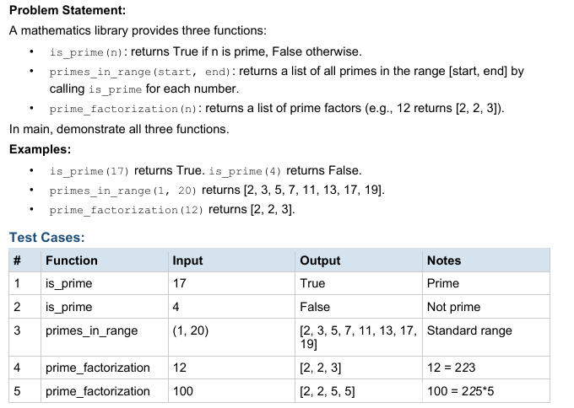
Code:
package lab5;

public class PrimeProgram {
// Function to check whether a number is prime
static boolean isPrime(int n) {

// Numbers less than or equal to 1 are not prime
if (n <= 1)
return false;

// Check divisibility from 2 to n-1
for (int i = 2; i < n; i++) {
if (n % i == 0)
return false;
}

return true;
}

// Function to print prime numbers in a range
static void primesInRange(int start, int end) {

// Check each number in the range
for (int i = start; i <= end; i++) {
if (isPrime(i))
System.out.print(i + " ");
}
System.out.println();
}

// Function to print prime factors
static void primeFactorization(int n) {

// Start checking from 2
for (int i = 2; i <= n; i++) {

// Print factor until it no longer divides n
while (n % i == 0) {
System.out.print(i + " ");
n = n / i;
}
}
System.out.println();
}

// Main method
public static void main(String[] args) {

// Test isPrime()
System.out.println(isPrime(17));
System.out.println(isPrime(4));

// Test primesInRange()
primesInRange(1, 20);

// Test primeFactorization()
primeFactorization(12);
primeFactorization(100);
}
}

Output:
